

Practices for Secure Software Report

Table of Contents
Document Revision History 3
Client 3
Instructions 3
Developer 4
1. Algorithm Cipher 4
2. Certificate Generation 4
3. Deploy Cipher 4
4. Secure Communications 4
5. Secondary Testing 4
6. Functional Testing 4
7. Summary 4
8. Industry Standard Best Practices 4

Document Revision History

Version | Date | Author | Comments
1.0 | 4/20/2025 | Daniel Hernandez

Client



Instructions

Submit this completed practices for secure software report. Replace the bracketed text with the relevant information. You must document your process for writing secure communications and refactoring code that complies with software security testing protocols.

- Respond to the steps outlined below and include your findings.
- Respond using your own words. You may also choose to include images or supporting materials. If you include them, make certain to insert them in all the relevant locations in the document.
- Refer to the Project Two Guidelines and Rubric for more detailed instructions about each section of the template.

Developer
Daniel Hernandez

Algorithm Cipher

For Artemis Financial’s application, I implemented the Advanced Encryption Standard (AES-256) cipher. AES-256 is a symmetric encryption algorithm widely used in financial institutions and government agencies because of its high level of security. It uses a 256-bit key size, offering strong protection against brute-force attacks. AES supports hash functions like SHA-256 to verify integrity. As a symmetric cipher, the same key is used for both encryption and decryption, which enhances performance and efficiency.

Certificate Generation

A self-signed certificate was created using Java Keytool to enable HTTPS for secure communication. The certificate is stored in a keystore file and the server reads it for SSL configuration.
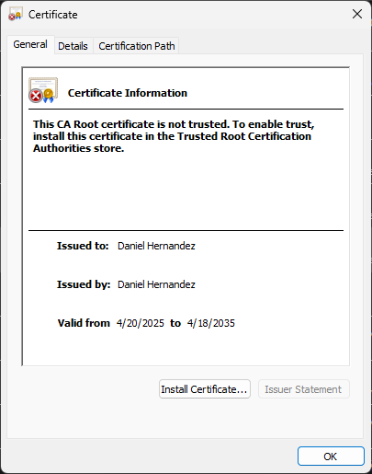
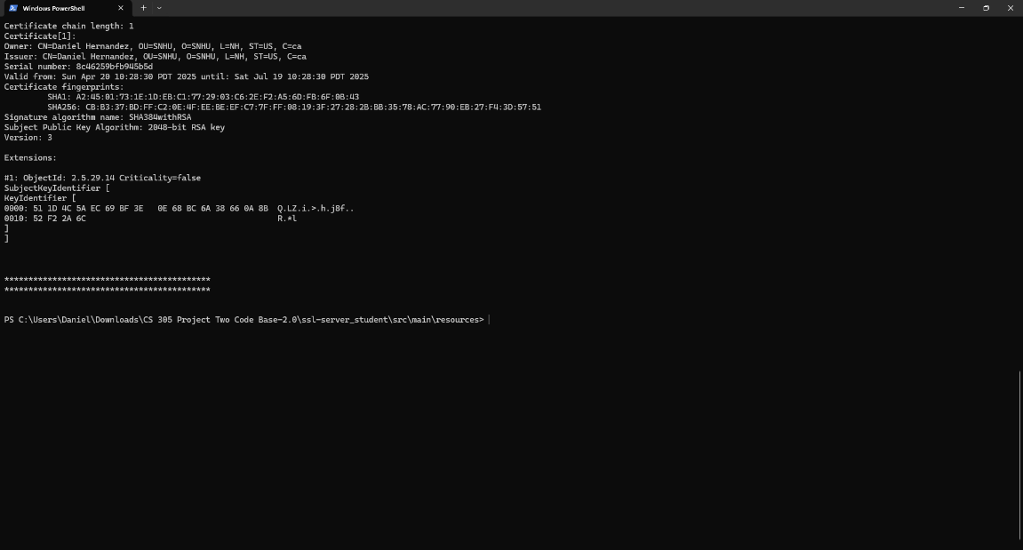

Deploy Cipher

The checksum was implemented using the SHA-256 algorithm. A static string including my full name was hashed and displayed at the endpoint '/hash'. This demonstrates the secure processing and verification of data.

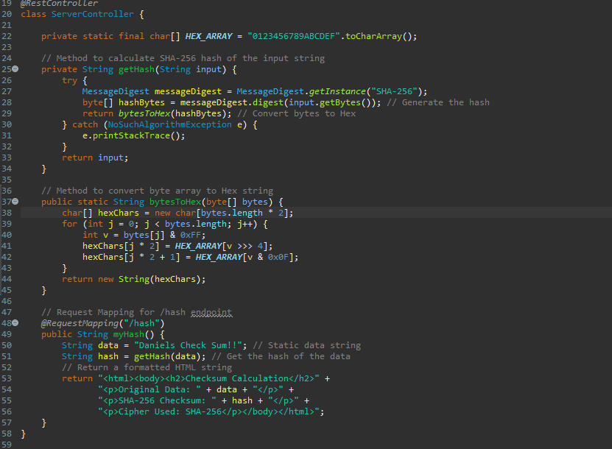
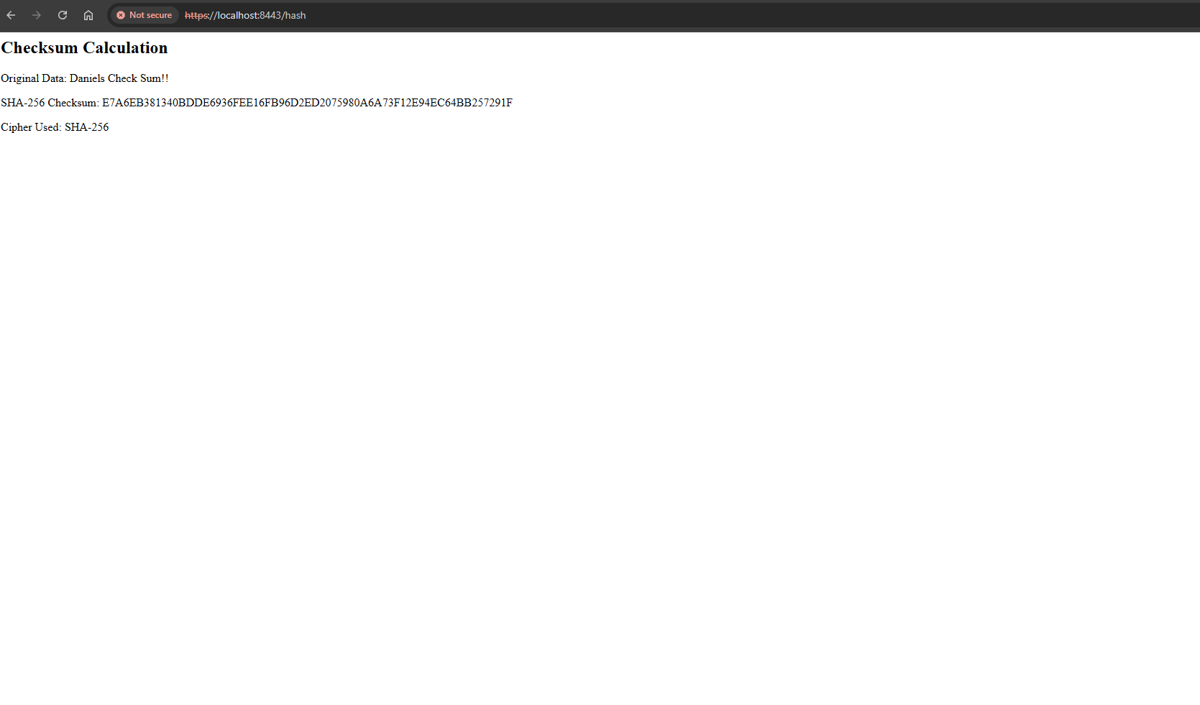
Secure Communications
HTTPS was enabled by configuring Spring Boot to use port 8443 and pointing to the SSL keystore file. Accessing https://localhost:8443/hash verifies the secure connection is working correctly.

Secondary Testing
Static testing using the OWASP dependency-check tool identified vulnerable dependencies. After suppressing false positives with a suppression.xml file and updating the pom.xml, a second scan confirmed no new vulnerabilities were introduced by the refactoring.

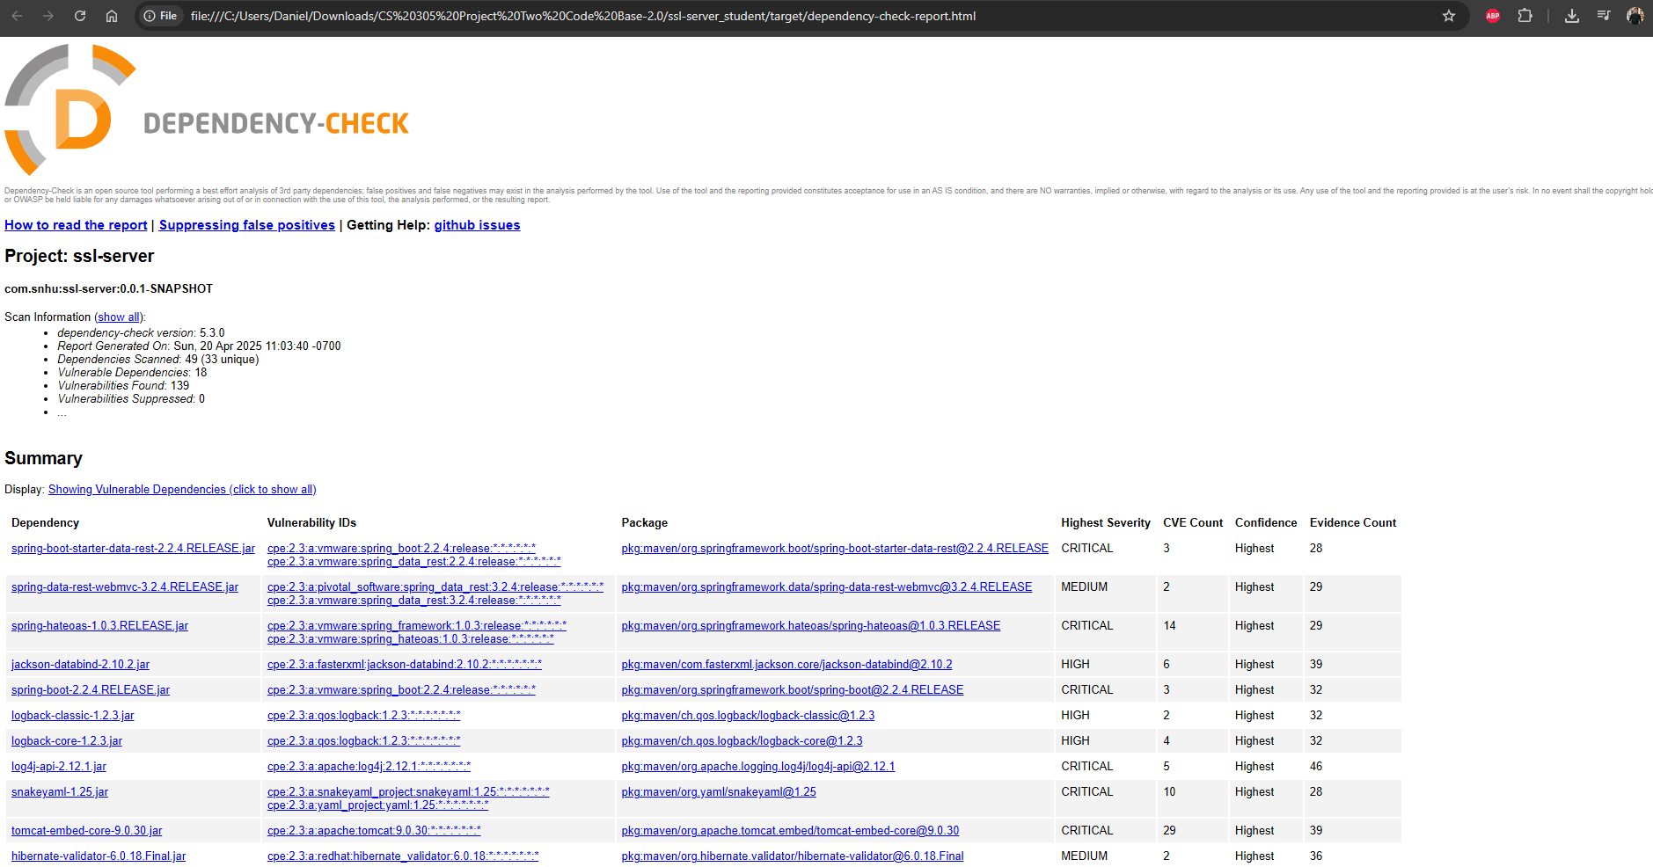

Functional Testing
The refactored code was run successfully, demonstrating the functionality of secure checksum generation and HTTPS communication.

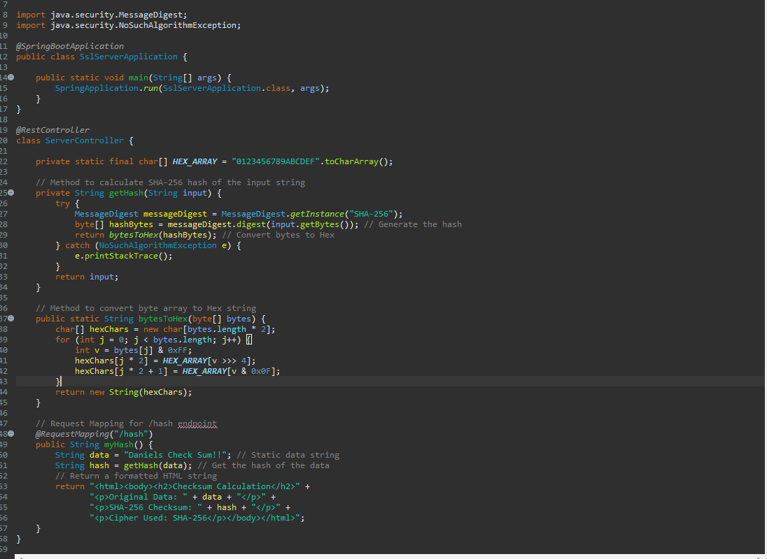

Summary

The code was refactored to implement AES-256 encryption, secure HTTPS communications using a self-signed certificate, and checksum generation with SHA-256. Static and functional testing confirmed the application meets security requirements. These changes improve Artemis Financial’s application’s resistance to tampering and eavesdropping.

Industry Standard Best Practices

Industry best practices followed include:
- Using AES-256, a NIST-approved encryption standard.
- Applying SHA-256 for strong collision-resistant hashing.
- Enabling HTTPS for all web traffic.
- Verifying dependency safety using OWASP tools.
These practices strengthen application security and ensure customer data confidentiality and integrity. Following established secure coding practices reduces attack surfaces and aligns with compliance regulations like GDPR and GLBA.

